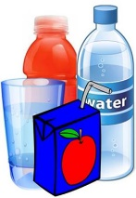
Forces, Fluids and Density Terminology
Use pictures, keywords, definitions, and/or examples to help you further understand the following terms. Use the textbook glossary or internet.
Particle Theory of Matter

Fluid

Viscosity

Density

Weight

Mass

Volume

Displacement Method

Buoyancy

Force

Floating

Balanced forces

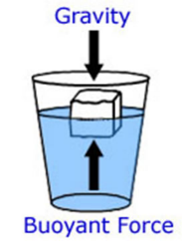
Gravitational force

Buoyant force

Newton (N)

Personal Floatation Device (PFD)

Archimedes’ Principle

Swim bladder

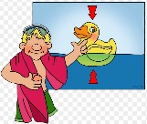

Ballast tanks

Plimsoll line

Contact force

Non-contact force

Hydraulic

Pneumatic

Pressure

Compressibility

Compression

Incompressible

Pascal’s law

Hydraulic systems

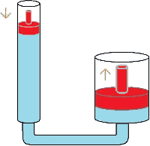
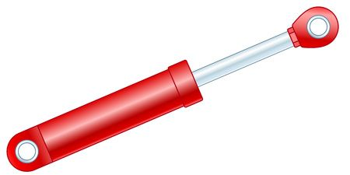

Hydraulic fluid

Input device

Output device

Mechanical advantage

Pump

Closed hydraulic systems

Open hydraulic systems

Pneumatic systems

Compressor

**Extra**

Convention tillage

**Extra** (pg. 258)

Conservation tillage

**Extra** (pg. 258)

No-till seeding

