Gr. 7-8 “Know Your Current Events” 5W
Article Title: ______________________________________________________
Author: ________________________(If applicable) Date: ___________________ (2 marks)
- WHO: (2 marks)
__________________________________________________________________________________________________________________________________________________________________________________________________________________________________________

- WHAT: (4 marks)
____________________________________________________________________________________________________________________________________________________________________________________________________________________________________________________________________________________________________________________________________________________________________________________________________________________________________________________________________________________
- WHERE: (1 mark)
______________________________________________________________________________

- WHEN: (1 mark)
______________________________________________________________________________

- WHY: (Why is this important? Why did it happen?)(2 marks)
____________________________________________________________________________________________________________________________________________________________
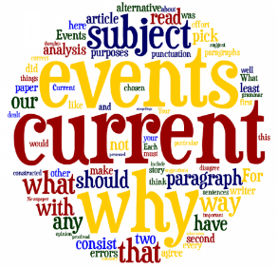

Name: ________________________________ NOTE: This can be done in point-form

Reliable websites:
www.cbc.ca
www.ctvnews.ca
www.globalnews.ca
www.cnn.com
www.bbc.com/news

